ADDING SOLVER REFERENCE TO VBA
this version: May 3, 2008
Overview 1
Recording a simple VBA routine using Solver: Excel 2003 1
Adding a reference to Solver in VBA 2

Overview
Suppose you wish to run a VBA routine that uses Solver. If you are running Excel 2003 and later, you will need to add a reference to your VBA sheet. All the Excel files for Financial Modeling, 3rd edition, have added this reference, but depending on the setup of your computer, you may need to make a minor change.
In addition, we discuss how to change over from Excel 2003 to Excel 2007.

Recording a simple VBA routine using Solver: Excel 2003*
Consider the following spreadsheet, in which we divide X by Y to get Z:
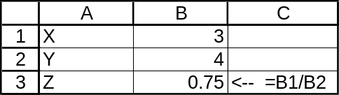
Suppose we want to use Solver to determine the X which gives Z = 6:
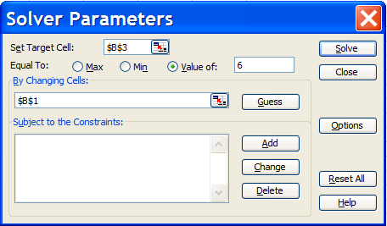
Suppose we record this macro by Tools|Macro|Record:
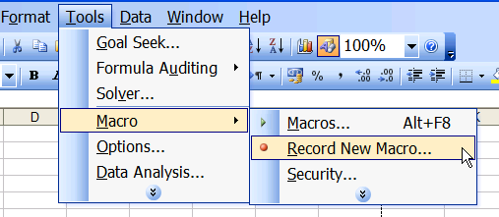
By opening the VBA window (press [Alt] + F11 ), you can see that this produces the following macro in VBA:
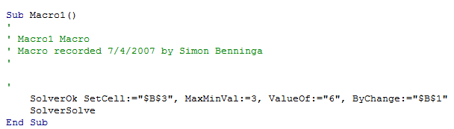

Adding a reference to Solver in VBA
To make this macro work, we have to add a reference to Solver in VBA. Open the VBA module by pressing [Alt] + F11:
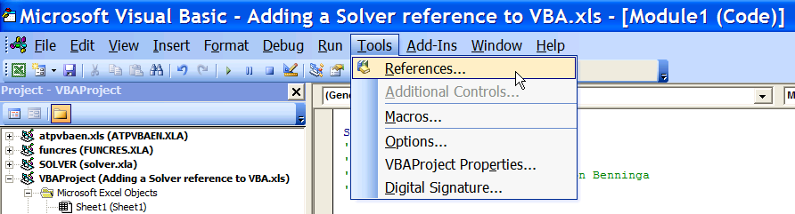
This brings up the following screen, on which you should click on Solver as shown below:
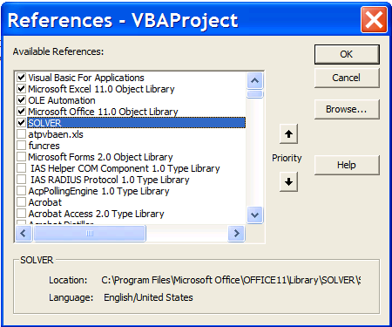
Notice the location of the author’s Solver. If your Solver is in the same location, the spreadsheet provided with Financial Modeling will work.

Adding a Solver reference in Excel 2007
Suppose you are using Excel 2007 and try to run the macro on page 344 of fm3_chapter12, Excel2003.xls . You press [Ctrl]+A and get the following error:
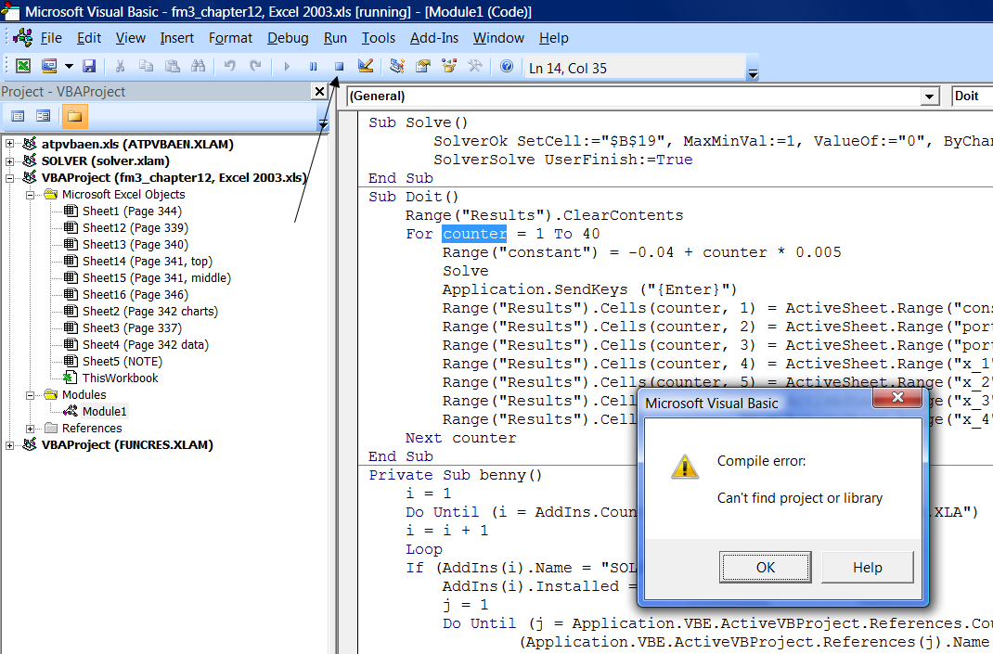
Click OK and stop VBA by clicking on the Reset button on the toolbar:
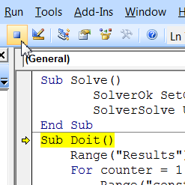

Now put in a different Solver reference by clicking on Tools|References:
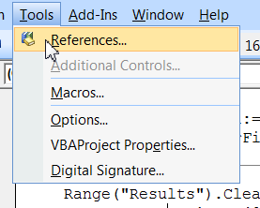
This brings up the following menu, which indicates that the Solver reference is missing:
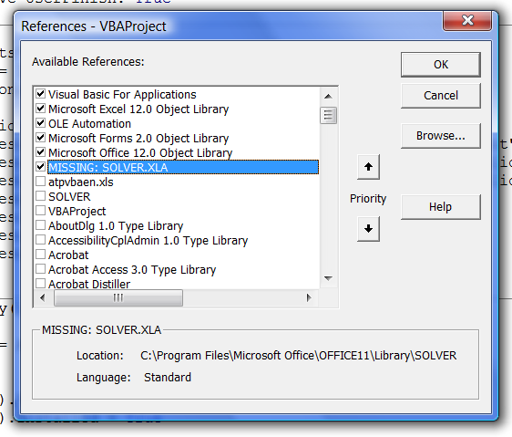
Unclick the MISSING: SOLVER.XLS reference and click on the Solver reference two lines below:
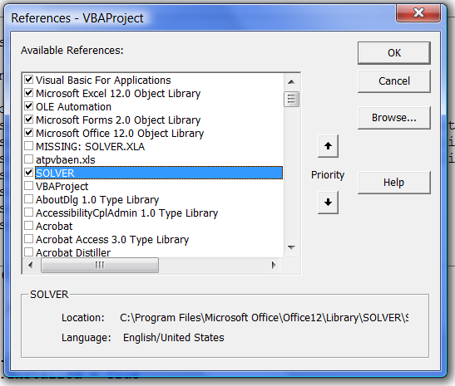
The macro should now work.

Note: If Solver does not appear in the above menu, you can usually find it by going to:
C:\Program Files\Microsoft Office\Office12\Library\Solver
And clicking on Solver.xlam .

* The example discussed in this section is written for Excel 2003, but the precise same logic follows for Excel 2007. Later on in this document we discuss the changeover from Excel 2003 to Excel 2007.

